**FARMERS PROBLEM GOT SOLVED!**

Link to open dashboard: <https://us3.ca.analytics.ibm.com/bi/?perspective=dashboard&pathRef=.my_folders%2Fcrop1&action=view&mode=dashboard&subView=model00000178ba1a15ad_00000000>

[18h61a05l0@cvsr.ac.in](mailto:18h61a05l0@cvsr.ac.in)

Pw:Sowmya@1234

Use the above credentials to open dashboard link.

Link to open demonstration video:

<https://drive.google.com/file/d/1BX3-uTn4I_5wo0Y8Bbg10B360VWnXVyE/view?usp=drivesdk>

There are many cases in India where many farmers do not get profits because of wrong selection of crop with in the existing weather and soil condition.

With the dataset containing different crop names,temperatures,rainfalls,soils we have prepared a dashboard containing different visualizations as visualizations actually make more sense(better to understand).

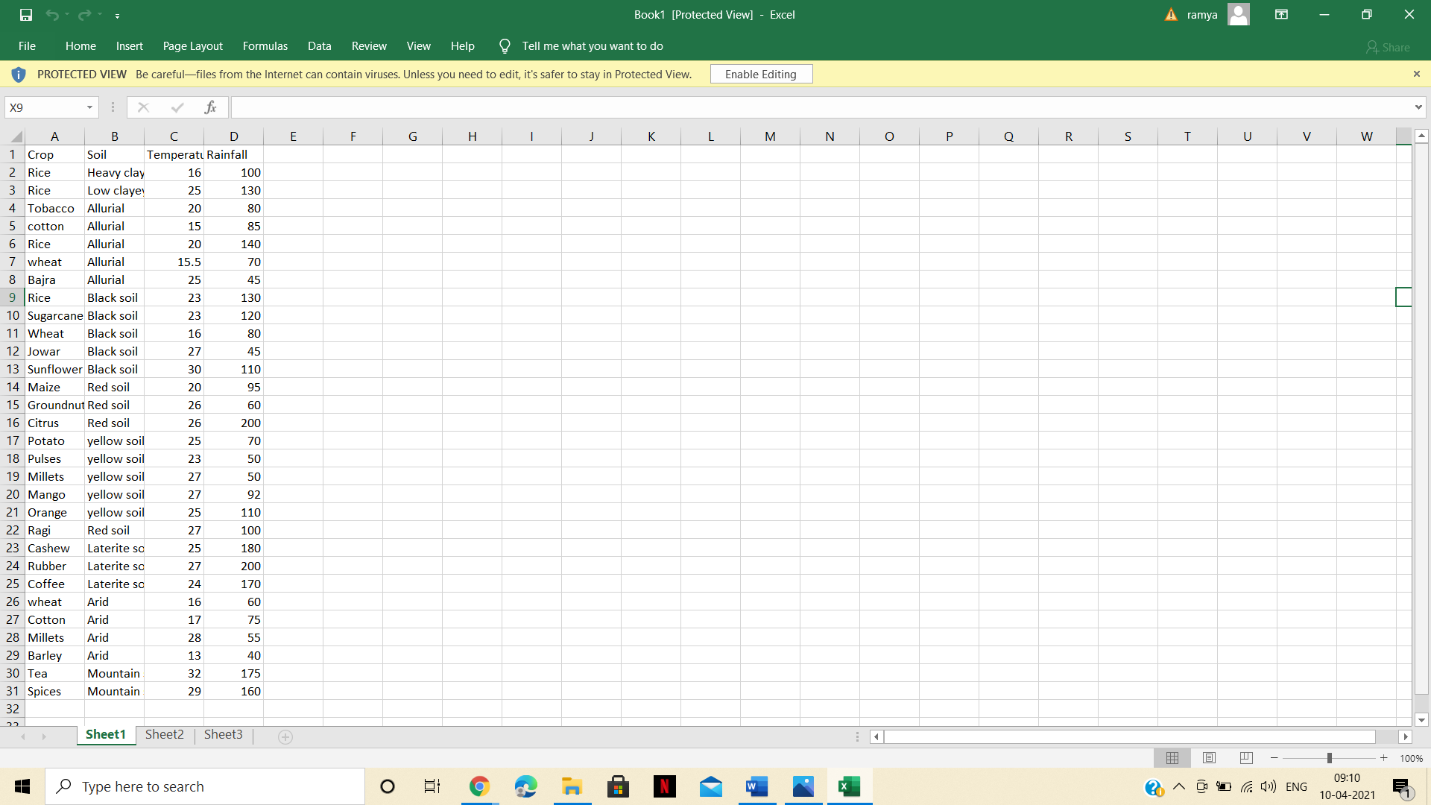

If the farmers have all the temperature, soil, rainfall information, then from the first 3 representations he can conclude which crop to raise. What I mean is, in the dashboard he can analyze the rainfall and crop in first column graph and he can filter some crops which are not suitable for his existing rainfall.

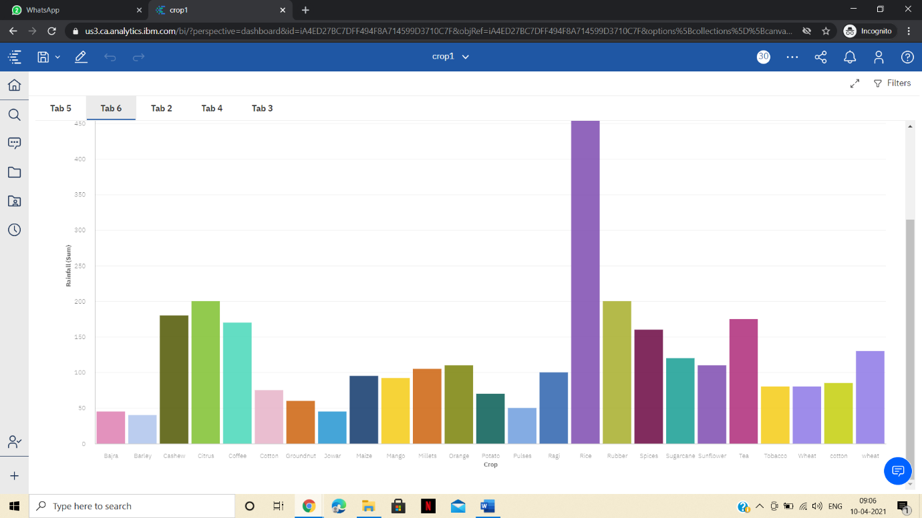

In the same way he can filter some crops from the second column graph if his temperature is not matching with crop’s temperature.

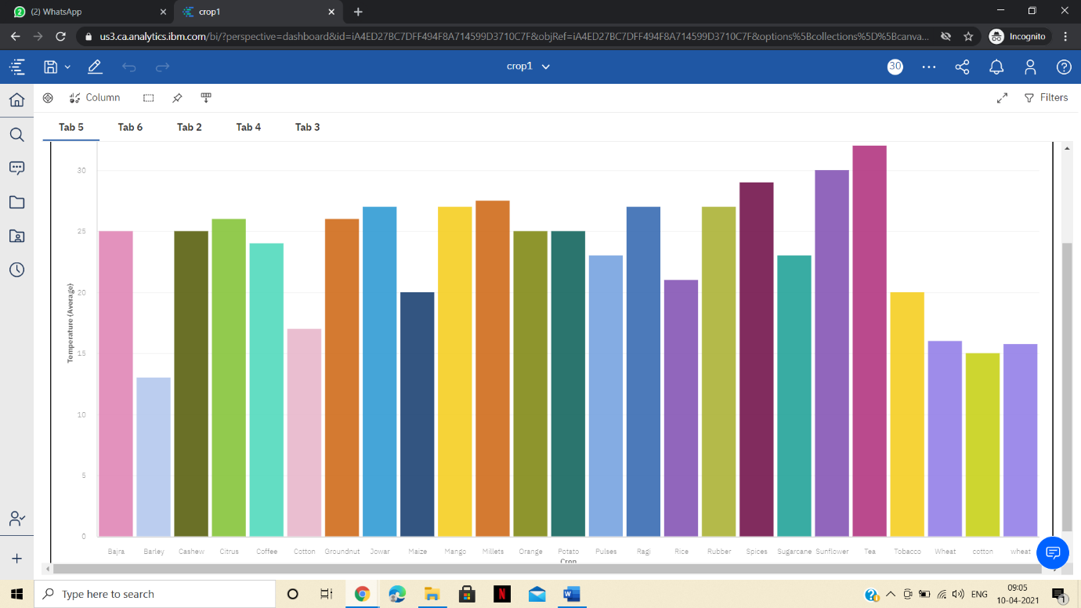

One can analyze both temperature and rainfall from following area graph.

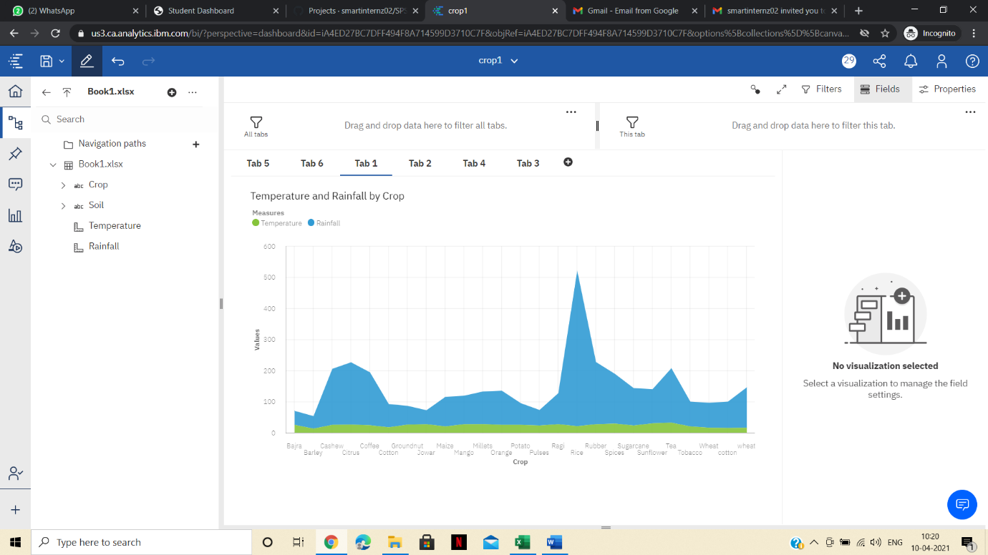

In the similar way he can filter other crops from the piechart which do not have soil as existing soil.

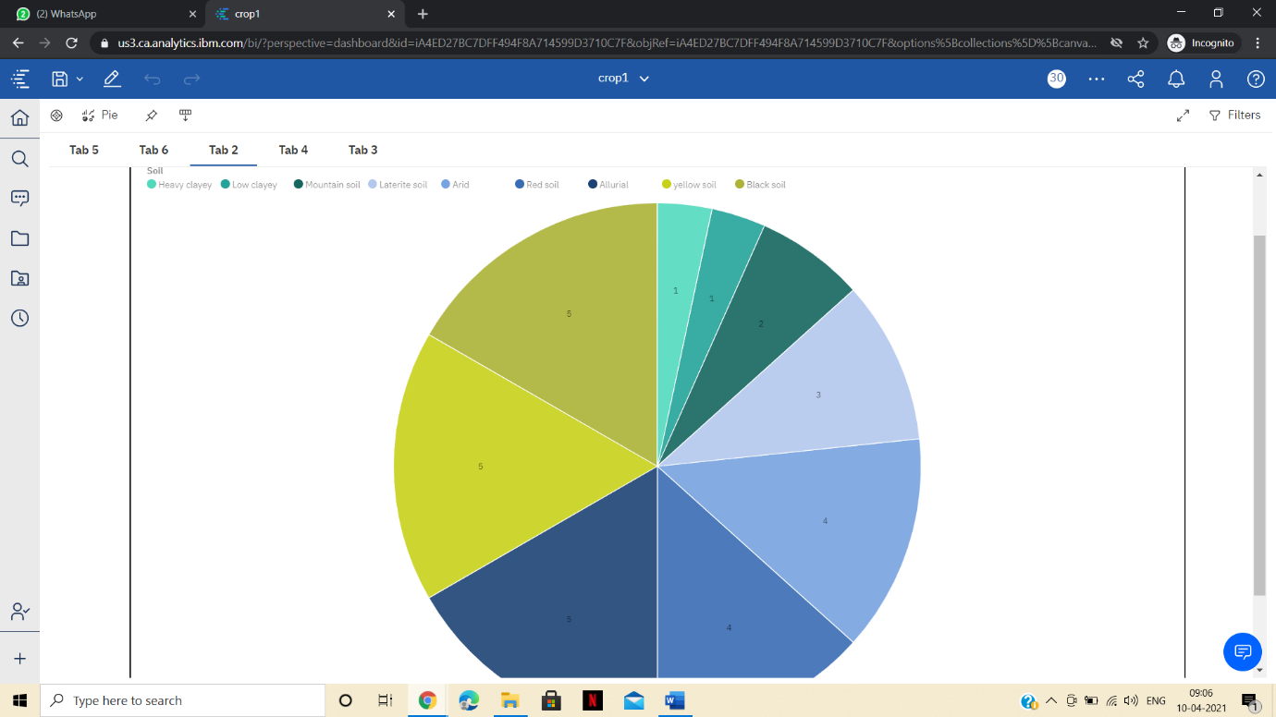

Now from the remaining crops. He can raise the crop as per his wish.

Other wise, he can also select some crops and analyze the table and can wait for the suitable weather conditions and soil conditions to occur in his area if possible.

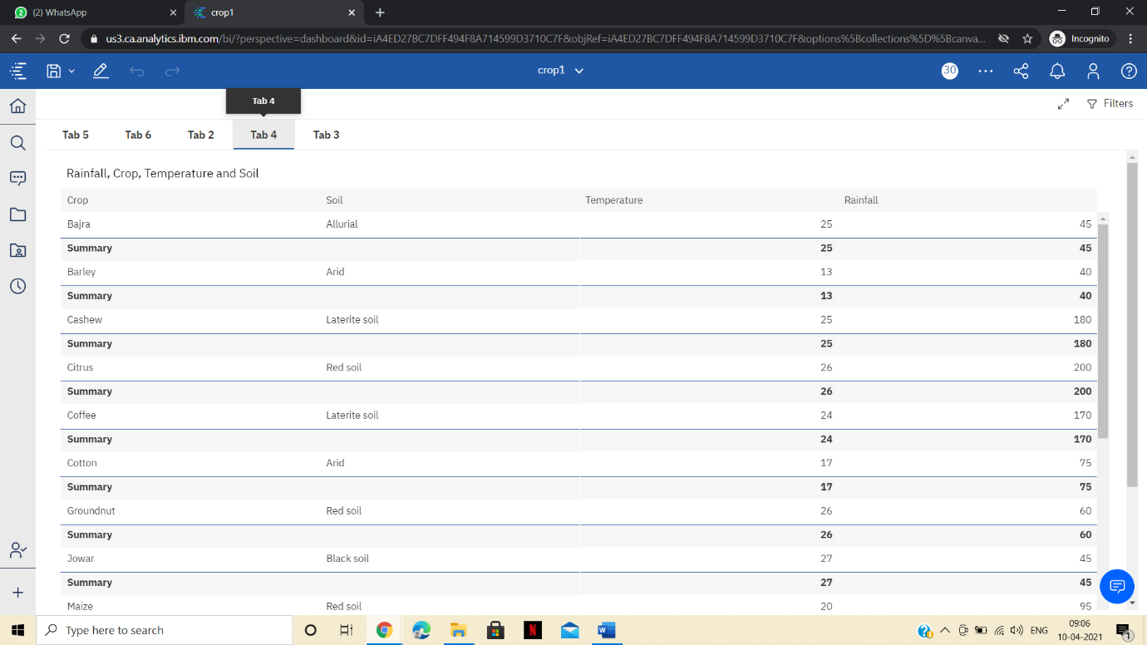

For example he can select a particular crop from column graph like rice and can analyze the conditions of it as shown below.

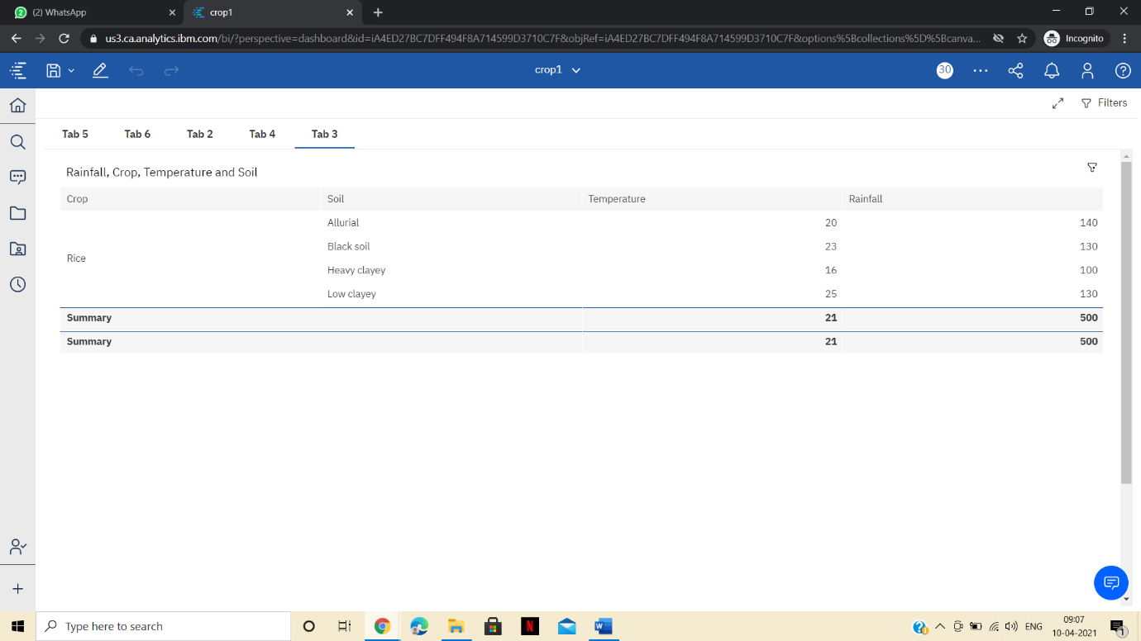

But this second way is bit complicated. So choose first way.

We can also implement this analyzing in the aspect of pests and pesticides that is we have to give a clarity to farmers to use only a particular pesticide for the existing pest.

This also works in terms of irrigation like telling them what irrigation to use for ex wheat rice requires more water so , we should recommend normal irrigation and for vegetables we can recommend drip and sprinkling irrigation.

This way of using analyzing definitely helpful to farmers.

THANKYOU.